Welcome to Pack 501!
Introduction to the ScoutLander Website and Database
(adopted from Alaska Troop 29 – used by permission)

What is ScoutLander?

ScoutLander is a free scout website and unit management system for scout units to organize events, simplify communication, create memories through photo albums, capture and retain lessons learned, and recruit new scouts.

Why ScoutLander?

Overall scout websites have only a 26% survival rate per year, most of which are maintained by a single Webmaster (administrator). The Webmaster driven website causes a bottleneck effect when it comes to updating content and events. When that Webmaster moves on to other things, the sites eventually die because no one is there to take their position.

ScoutLander was designed to fix this problem by getting everyone involved in the beginning. Studies show that the best people to maintain website integrity are not the people who organize the events but the people who rely on the information. The content is the responsibility of not only, adults, but more importantly, the youth.

What does ScoutLander Do?

Public Site
These are the sites that can be accessed by anyone without logging in. Presently, these include descriptions of Scout and Adult leadership descriptions, links and attachments of helpful forms and resources, and a site help page.
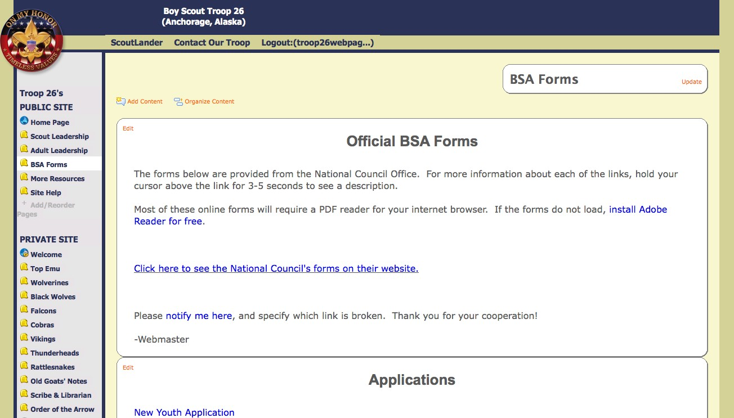

Private Site
Secure information is protected and kept here by requiring an account and password to
see. All of your scout's names and personal information are safe and can only be seen by members of Pack 501.



Public Pages
Private Pages Personal Information Photos
Events Etc.

Den Pages
Kept updated by the Den Leader, any info that the Den feels valuable will make its way on to the page.
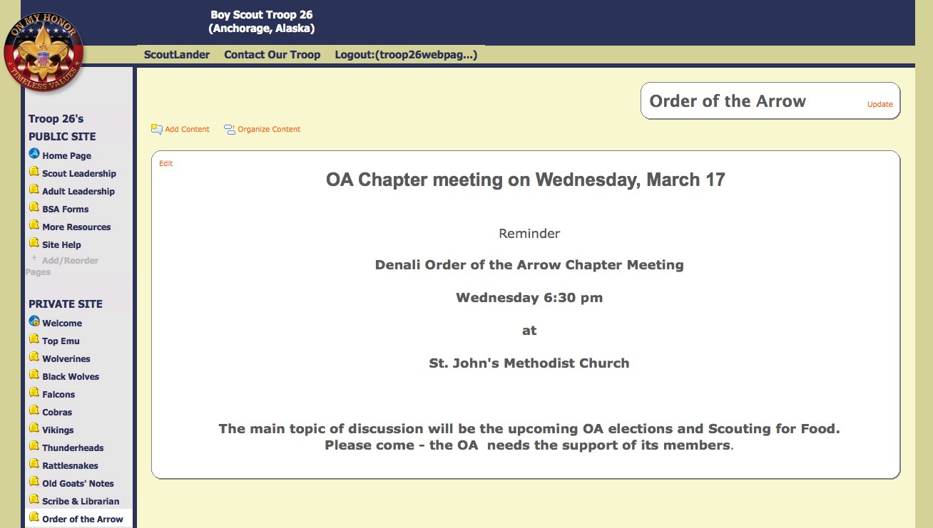

“My Profile”
You can edit your personal information here, along with changing your password. We
would like for everyone to fill in as many blanks as possible to help with our records.
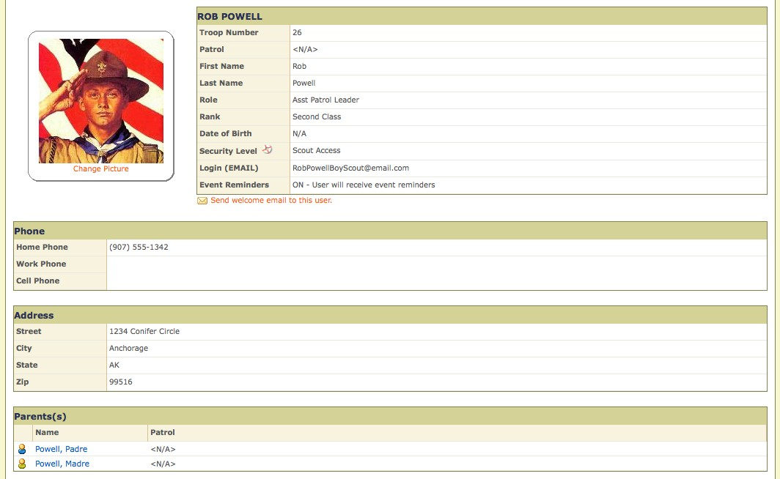

Event Calendar
One of the most useful features of the site is the Event Calendar. Here, leaders can add Pack, Leader, and Den events for others to see. It can send out reminders of the event to the Pack 48 hours before the event starts and has a built in RSVP feature. Photo albums in the Photo Gallery can be matched with the event in the calendar.
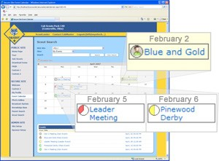

Photo Gallery
Upload your best shots from a scouting event for others to see, and even tag the names of
the Scout or Adult featured in the photos. Photo albums are easily matched with an event in the Event Calendar.
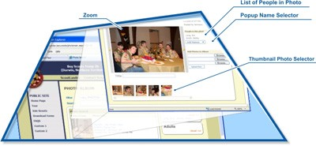

Broadcast System
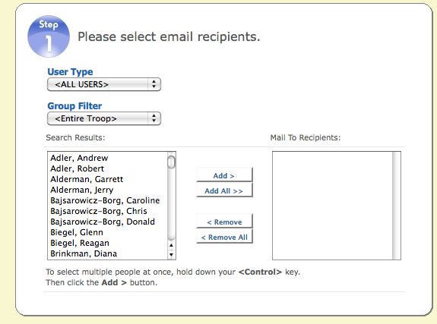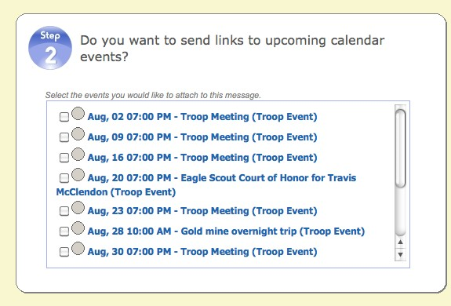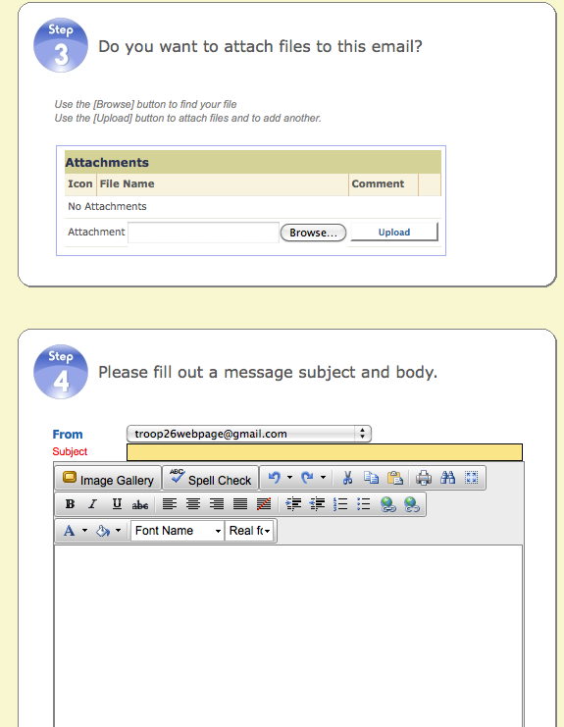Need to send someone an email, but don't know their email? Just find their name in the list and send them a quick message. You can also send emails out to a group of people, such as your den or even the entire Pack. Emails will stay updated because users have access to edit their own info.

Knowledge Base
Notes and other information from presentations and demonstrations during meetings can get uploaded here, where Scouts and Parents that could use this knowledge in the future can find them. You can select the article to be shared with the global scout community, and search for knowledge posted by other Scouters around the world.
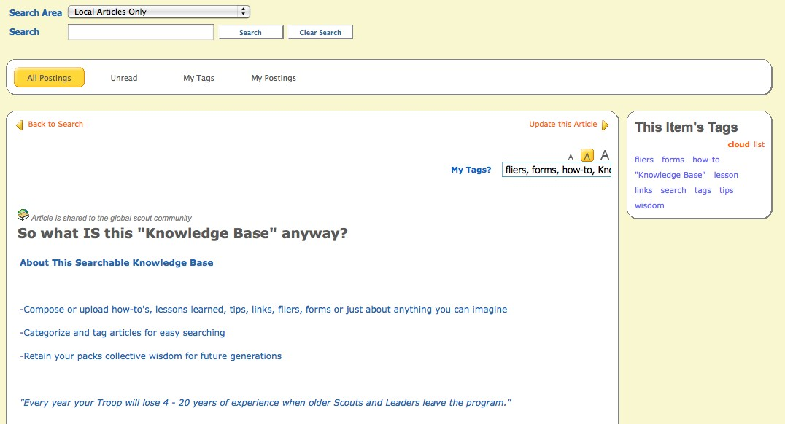

Scout Search
Includes a list of all of the scouts in Pack 501, along with their information and links to
their parents.
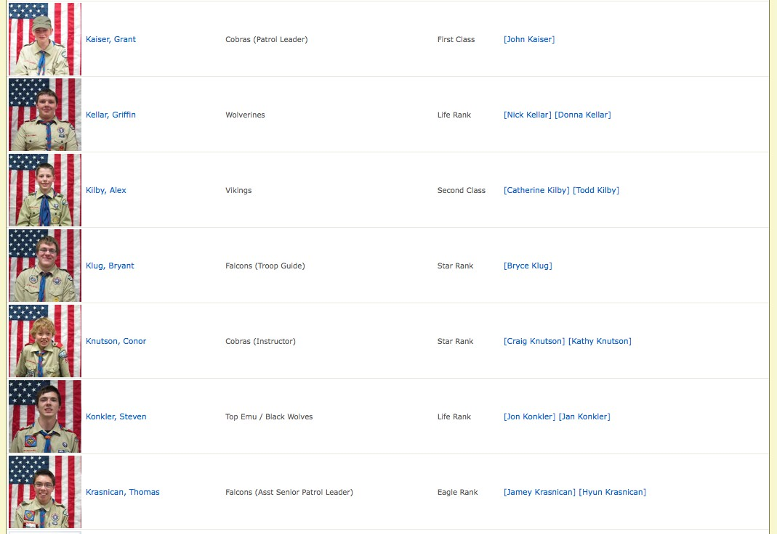

Adult Search
This is the same as the Scout Search, but listing all of the Pack 501 adults.

Help
Answers to some frequently asked questions, video tutorials, step-by-step instructions, and contact info for the Webmaster.

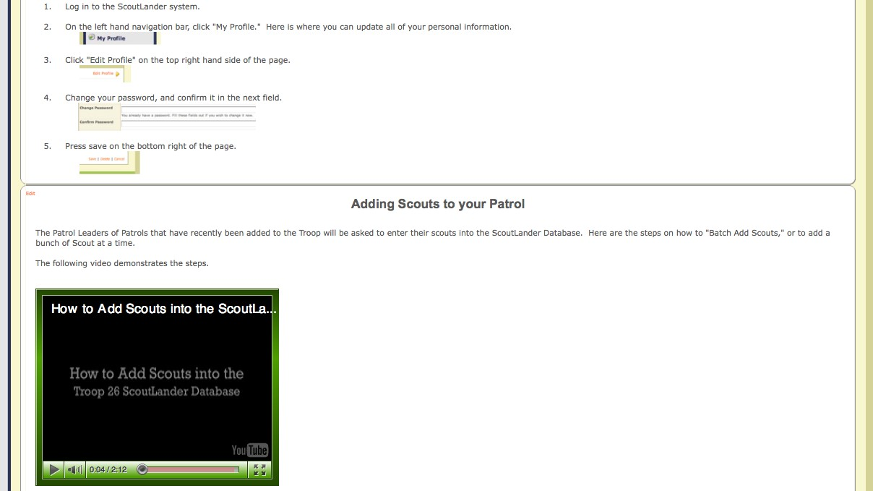

For more information:
Visit the website: http://www.pack501varinava.scoutlander.com/
Webmaster: pekej600@verizon.net

Pack 501 Scoutlander Introduction
Published October 10, 2011
Rev 1

